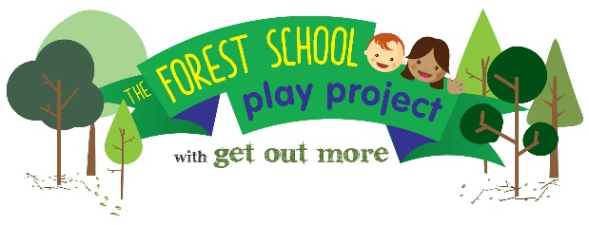

NOCN Level 1 Introduction to Forest School Training:
9am – 4pm 21-23 February 2023

An introduction to the ethos and principles of Forest School for early years workers and parents involved in Better Start Bradford’s Forest School Play Project.

Level 1 Course Outline: Annie Berrington of Get Out More CIC will introduce the concepts of forest school and a range of basic woodland skills. The course will allow participants to look at using the outdoor environment to facilitate different learning styles and to encourage the development of personal skills such as confidence and self-esteem.

Participants will learn how the outdoors can be used to encourage all areas of development, understand factors that affect children’s behaviour and strategies for the outdoor environment. We will also look at how the outdoor environment encourages independence, self-reliance and self-esteem and promotes healthy, balanced social and emotional growth.

- Course takes place at the meeting room at Bowling Park Lodge Cafe, Bowling Hall Road, Bradford BD4 7TL and outdoors within the park.
- It is a requirement of the course that trainees attend all three training days.
- Portfolio completion will take place during the course and be handed in on the last day.

Target group:
This course is ideal for those people who are wanting to gain skills for working outdoors with children and young people, those who want to explore Forest Schools within their own setting or those who wish to support a trained Forest Schools practitioner. The course has been programmed for early years workers and parents of young children from the Better Start Bradford area.

Place allocation:
Each setting currently engaged in the Forest School Play Project is offered up to 3 FREE places on this course for their EARLY YEARS STAFF OR PARENTS OF CHILDREN WITHIN THEIR NURSERY, (normal course cost: £250 per place). Further places are available to other adults living or working in the Better Start Bradford area who can use the training to benefit children aged 0-3 and their families.

To book their places, settings need to complete the application form and return it to Sam Colman sam@getoutmorecic.co.uk or to the above postal address.

Places are awarded to eligible participants on a first come first served based so please return the form as soon as possible

The Forest School Play Project and Better Start Bradford: This course is part of The Forest School Play Project, a Better Start Bradford project, being delivered by Get Out More between 2018-2024. This programme offers hundreds of young children and their families in Bowling & Barkerend, Bradford Moor and Little Horton the chance to experience the benefits of nature-based learning through engaging with forest school.

