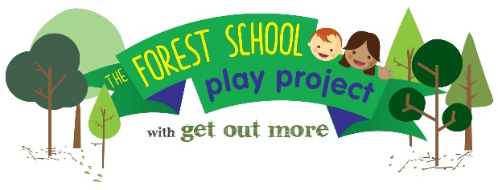

NOCN Level 1 Introduction to Forest School Award: 13 – 15 June 2023

APPLICATION FORM FOR PARENTS

NAME
EMAIL ADDRESS
PHONE NUMBER
NAME AND ADDRESS

The funding for this course comes from Better Start Bradford to support parents of children aged 0-3 from the Better Start Bradford areas; Bowling & Barkerend, Bradford Moor and Little Horton

How old are your children?
Do you require childcare for your children to enable you the course?

It is a requirement of the course that trainees attend all 3 days in full

If I am selected for the course, I commit to attending all 3 days in full

Applicants signature Date

Please respond to the following 2 questions. Boxes will expand as required.

- 1. What experience do you have of outdoor play with children?

- 2. Why do you want to do the Forest school Level 1 training?

Return it to Sam Colman sam@getoutmorecic.co.uk or to the above postal address.

Places are awarded to eligible participants on a first come first served based so please return the form as soon as possible

