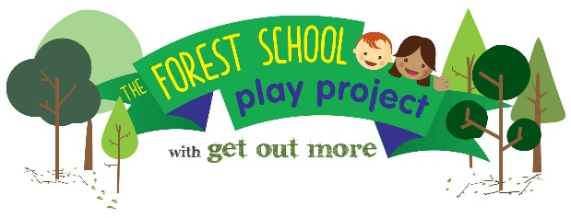

NOCN Level 3 Forest School Practitioner Award:

22-26 May 2023 and 27 Nov – 1 Dec 2023 at Bowling Park, Bradford

APPLICATION FORM

NAME
EMAIL ADDRESS
PHONE NUMBER

I am applying as: (tick one only)

Parent of child aged 0-3 years, living in the Better Start Bradford area

Early Years worker, working with children aged 0-3 in the Better Start Bradford area

If parent; HOME ADDRESS INC POSTCODE

If Early years worker: NAME AND ADDRESS OF EMPLOYER
POSITION
MAIN RESPONSIBILITIES

It is a requirement of the course that all trainees attend all training days in full including the first aid training.

If I am selected for the course, I commit to attending all forest school and first aid training days in full

Applicants signature Date

Early Years workers only: Trainees are expected to implement learning from the course within their setting, for the benefit of young children in the Better Start Bradford area.

I agree to support the applicant in implementing learning from the course within our setting

Line Manager’s signature Date

All applicants must complete the following 3 questions. Please give details; answers to each question should be between 100-200 words
Boxes will expand as required.

- 1. Please give details about any past experience you have working within an outdoor environment, including any examples where you have worked with children.

- 2. Why do you wish to do the Level 3 Forest School Practitioner course?

- 3. How will you use this training to improve outcomes for young children in the Better Start Bradford area?

Return the form by email or post to Sam Colman

sam@getoutmorecic.co.uk
Get Out More CIC, AES Orchard, Sunderland St, Keighley, BD21 5LE

