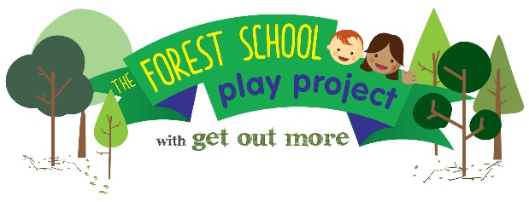

NOCN Level 3 Forest School Practitioner Award:

22-26 May 2023 and 20-24 Nov 2024 at Bowling Park, Bradford

Level 3 Course Outline:
This course is an opportunity to explore to a higher-level different approaches to using the outdoor environment in a Forest School setting and is for those who and wish to coordinate, manage and lead Forest School Sessions with children, young people or adults.

Lily Horseman of Kindling Play and Training will deliver an accredited course that inspires and excites participants whilst providing all the theory, skills, and knowledge necessary to set up and lead a forest school programme. The course guides learners through an enjoyable, supportive learning process with clear, easy to understand teaching materials. The course is taught inside and outside through a mixture of games, practical activities, reflection, and creative presentations

Target group:
Better Start Bradford are funding free places for early years workers and parents living or working in the Better Start Bradford area, (Bradford Moor, Bowling and Barkerend and Little Horton: Better Start Bradford postcode checker: https://www.betterstartbradford.org.uk/about-us/our-part-of-bradford/).

Eligible trainees will be able to apply their training to run forest schools with children aged 0-3 in the Better Start Bradford area. Trainees must attend both training weeks and complete the first aid course and portfolio work – see below.

The Forest School Level 3 course is aimed at individuals who have a minimum Level 2 qualification in Youth Work, Child Care, Teaching, or relevant experience in working with children. The level 3 qualification equips trainees with the skills and accreditation to lead forest schools.

Course content:
You will investigate how best to design and run a Forest School programme and look at how to approach and apply it safely and effectively. The course content of this qualification is based on up-to-date research surrounding aspects of:
- Holistic development
- Neuroscience
- Theories of Learning and Development
- Woodland conservation, history and management
- Wellbeing and nature connection
- Risk benefit assessments
Course Duration
- Initial training week – consisting of 5 days of training 22-26 May 2023
- Portfolio work – candidates take away their portfolio to work on (For about 7 months)
- First Aid – Candidates complete a 2 day ITC outdoor paediatric first aid course
- Second week – Consisting of 5 days of further training and benchmarking 20-24 Nov 2024

Participants on this course will need to complete a paediatric outdoor First Aid 2 day course before completing their Forest School training. (Better Start Bradford trainees will receive a funded place on a local first aid course).
Learners are assessed in their learning through the submission of 20 assessment tasks, completed throughout the course. Some tasks will be completed during the training, and some will be written up in between the taught sessions. Participants on the course will need to plan and deliver 6 Forest School sessions with the same group of children.

The Forest School Play Project and Better Start Bradford: This course is part of The Forest School Play Project, a Better Start Bradford project, being delivered by Get Out More over the next 3 years. This programme will offer hundreds of young children and their families in Bowling & Barkerend, Bradford Moor and Little Horton the chance to experience the benefits of nature-based learning through engaging with forest school.

The course is free to trainees and there are only 12 places available, therefore places will be awarded on merit following an application process. Please complete the application and return it to Sam Colman (sam@getoutmorecic.co.uk) or at the above postal address

